AV Inventory Ticketing Management System

Project Description
The AV Inventory Ticketing Management System will be utilized to request AV equipment for classrooms, presentation facilities and theater from Faculty and Staff to the AV department. The system will allow the AV department to know when a work order has been submitted with the given date/s, time/s, location and type of equipment. It will be also used to keep track of equipment inventory and assigned deliveries to AV staff throughout the day

Project Goals
The proposed AV Inventory Ticketing Management System will provide Triton College the benefits of a system that will allow their staff and faculty make requests and delivery of instructional equipment for classrooms or events while keeping track of the inventory at hand. Faculty will be able to browse through the online information database and visually search and schedule the delivery of the equipment they have in mind by using various search criteria. On the other hand the system will provide to the AV department the ability to accurately track orders and inventory real-time.

Use Cases
For this project we will implement the Use Case methodology. A series of vignettes and stories have been developed to describe how people will use the new system. For this system, we have two distinct types of users with distinct requirements and needs – AV-Staff and faculty.

AV-Staff
The AV-technician who works for the Audio & Visual (AV) department handles all requests related to AV equipment for the College, such as laptops, projectors, microphone systems, video and audio recorder equipment etc.
Every morning as part of AV-technician duties is to create individual work orders for each request made and deliver the equipment to the respective location.
Manages inventory data
Keeps track of open and close work-orders

Faculty

Faculty members submits a number of AV equipment requests. The equipment is typically utilized for either group presentations or classroom purposes.
Equipment ranges from laptops, projectors, microphone systems, video and audio recorder equipment etc.
Searches inventory data
Makes request based on needs

Author | Humberto Espino
Date | July 25, 2017
Version | 1.0
Use-case name | Elaine, AV-Staff – Open and closing work-orders based on date and time.
Use-case number
Priority

Source | Inventory Data | Requests
Primary business actor | Staff
Other participating actors | Paul, Faculty member – Makes a request of specific equipment to be delivered by Elaine based on date and time
Interested stakeholders | AV-Department / Faculty
Description | The process starts from Paul browsing through the online inventory database and visually search and schedule the delivery of the equipment they have in mind by using various search criteria
Typical course of events | 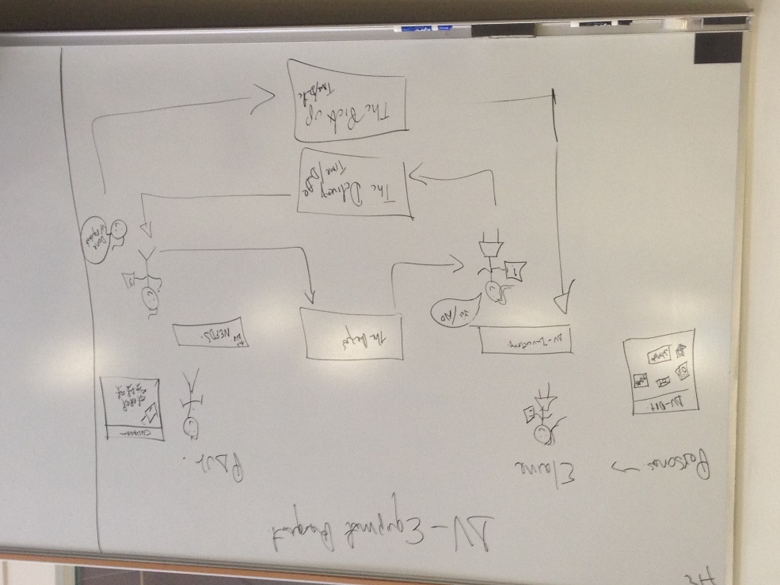  - Paul searches thru the inventory database for available equipment  - Selects available equipment that best suits his needs  - Makes a request for delivery which includes date and time  - System creates a work-order as open and holds equipment  - Elaine, checks system for daily assigned work-orders  - Based on time of the day, is either pick-up or delivery of equipment.  - If delivery – Elaine scans-out equipment code and changes status of the work-order to Pick-up  - If pick up- Once equipment is back, Elaine changes the status of the work-order to closed and scans-in equipment code.  - As work-order status changes to closed, system makes the equipment available for the next request.  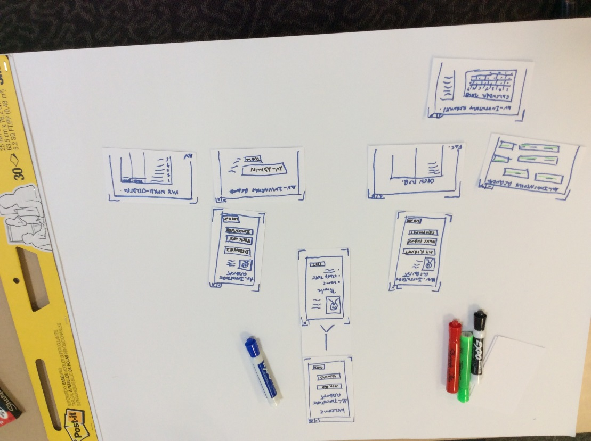
Alternate courses

Conclusion | This process will keep track of inventory equipment real-time as AV-department and Faculty will know what equipment is available and will reduce the number of inventory errors.  The new system will simplify user operations by the integration of the equipment inventory system with staff/faculty delivery request work-order system. The proposed system should make it easier to track orders and remove the manual operations that are currently required to keep both inventory and delivery request systems in synch.  Tracking orders -The system will be able to insert records into the database via the web form and generate work-order per request so that the av-department will not need to manually create work-orders. In addition the system will provide the ability to close orders via the online web form.
Post-condition | Equipment is scanned in and out at all times.
Business rules | -All equipment status, descriptions, locations will need to be provided in the inventory data  -Faculty information needs to be validated  -Work-order tracking needs to be part of the system  -Administrative access for AV-Staff that allows inventory updates
Implementation constraints and specifications | This system proposes to integrate components from two distinctive systems into one, it will be written in Java along with HTML5, ColdFusion code and SQL language. It will utilize the email component of the current system, and will also introduce new technologies components for handheld devices.
Assumptions | Assumes that tracking of equipment and requests will be done thru the system.
Open issues | TBD

